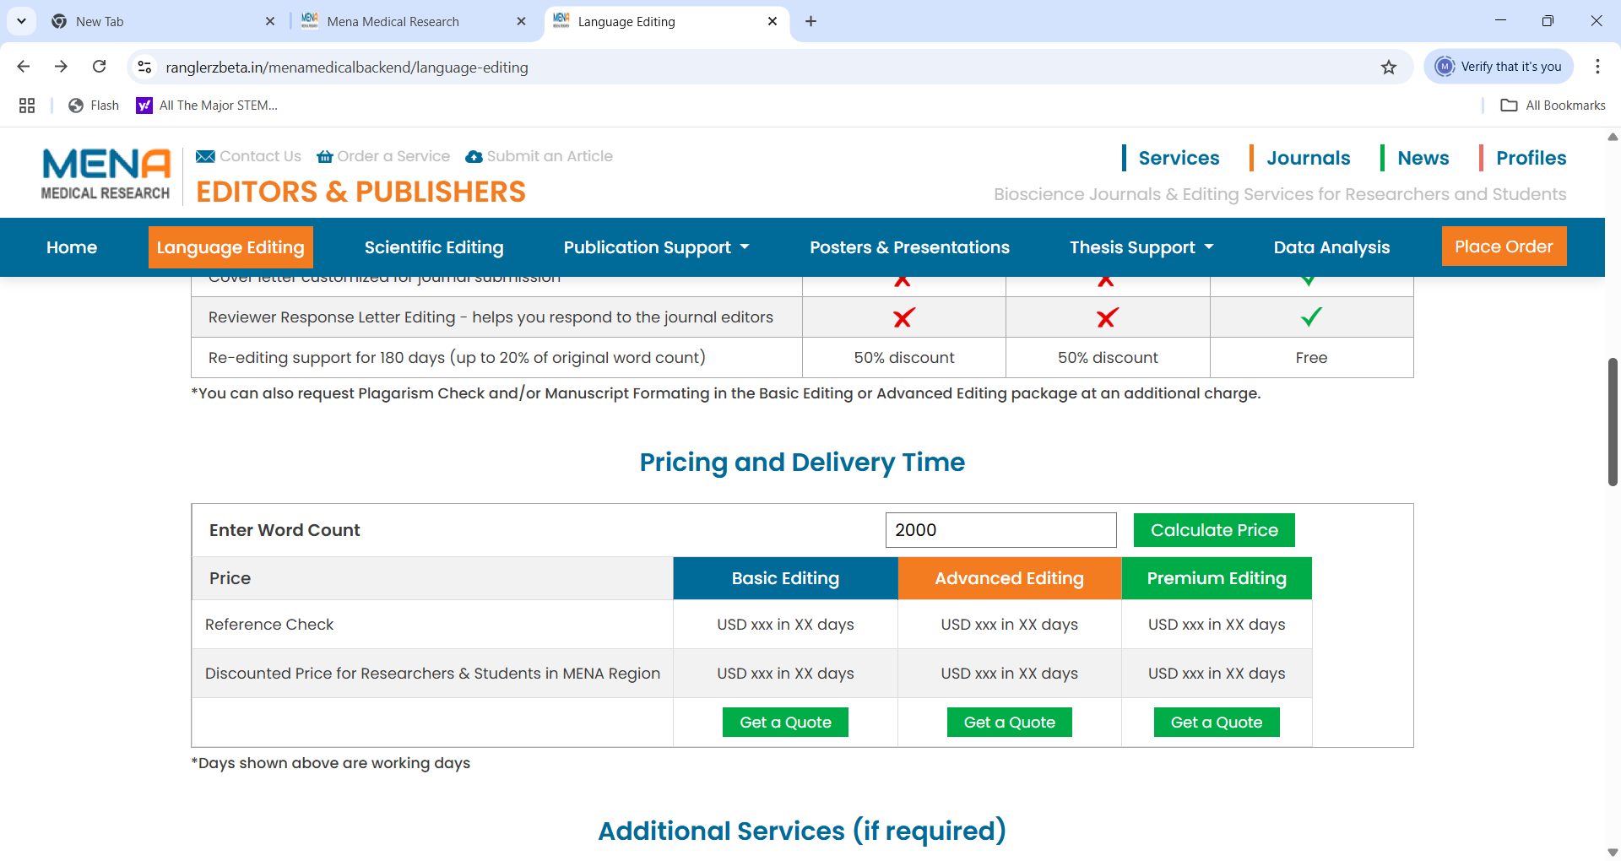

MENA Medical Research has a transparent pricing policy. We ensure that you are aware of our service charges and make a fully informed decision before placing an order.

Price and Delivery Time for language editing service depend on the level of service required (Basic, Advanced, Premium) and the word count of your document. You can select the required service to find the estimated price, before submitting your request for work.

**Select**

**Select**

**Select**

**Place Order & Pay**

You place order for required services and make the payment

You submit document for preliminary review and invoice creation

**Scientific Editing**

MENA Medical Research has a transparent pricing policy. We ensure that you are aware of our service charges and make a fully informed decision before placing an order.

Price and Delivery Time depend on the word count of your document. You can find the estimated price before submitting your request for work.

**Get Price Estimate**

You submit document for preliminary review and invoice creation

**Place Order & Pay**

You place order for required services and make the payment

**Assignment Editing**

MENA Medical Research has a transparent pricing policy. We ensure that you are aware of our service charges and make a fully informed decision before placing an order.

Price and Delivery Time depend on the word count of your document. You can find the estimated price before submitting your request for work.

**Get Price Estimate**

**Place Order & Pay**

You place order for required services and make the payment

You submit document for preliminary review and invoice creation

**Thesis Editing**

MENA Medical Research has a transparent pricing policy. We ensure that you are aware of our service charges and make a fully informed decision before placing an order.

Price and Delivery Time for thesis editing service depend on the level of service required (Advanced or Premium) and the word count of your document. You can select the required service to find the estimated price, before submitting your request for work.

**Select**

**Select**

You submit document for preliminary review and invoice creation

**Place Order & Pay**

You place order for required services and make the payment

**Accidental Plagiarism**

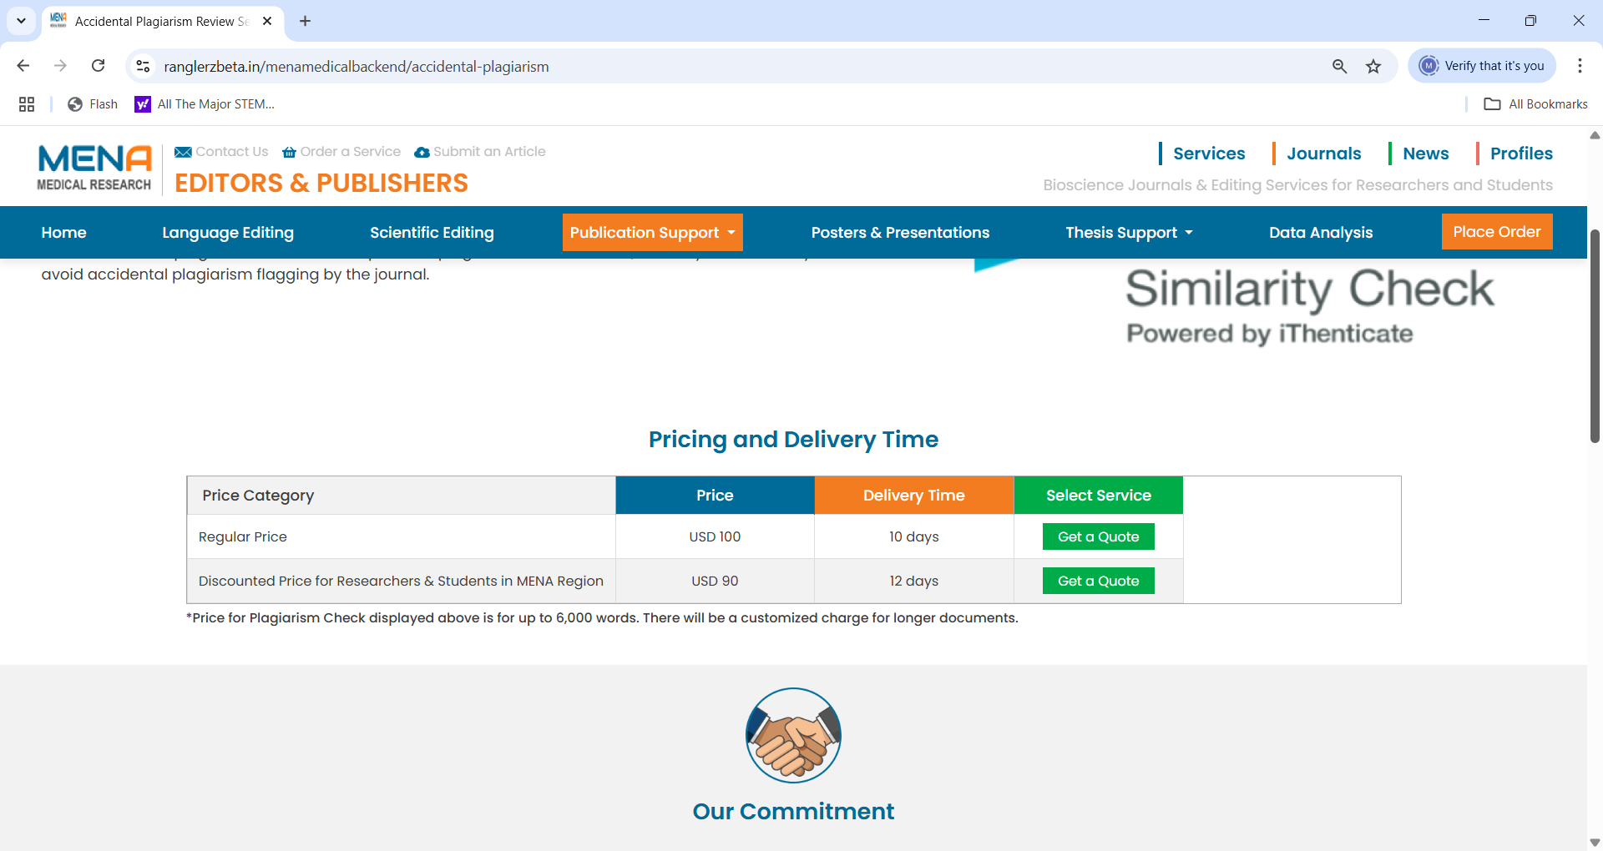

MENA Medical Research has a transparent pricing policy. We ensure that you are aware of our service charges and make a fully informed decision before placing an order.

Price and Delivery Time depend on the word count of your document. You can find the estimated price before submitting your request for work.

**Get Price Estimate**

**Place Order & Pay**

You place order for required services and make the payment

You submit document for preliminary review and invoice creation

**Manuscript Formatting**

MENA Medical Research has a transparent pricing policy. We ensure that you are aware of our service charges and make a fully informed decision before placing an order.

Price and Delivery Time depend on word count of your document. You can find the estimated price before submitting your request for work.

**Get Price Estimate**

You submit document for preliminary review and invoice creation

**Place Order & Pay**

You place order for required services and make the payment

**Posters and Presentations**

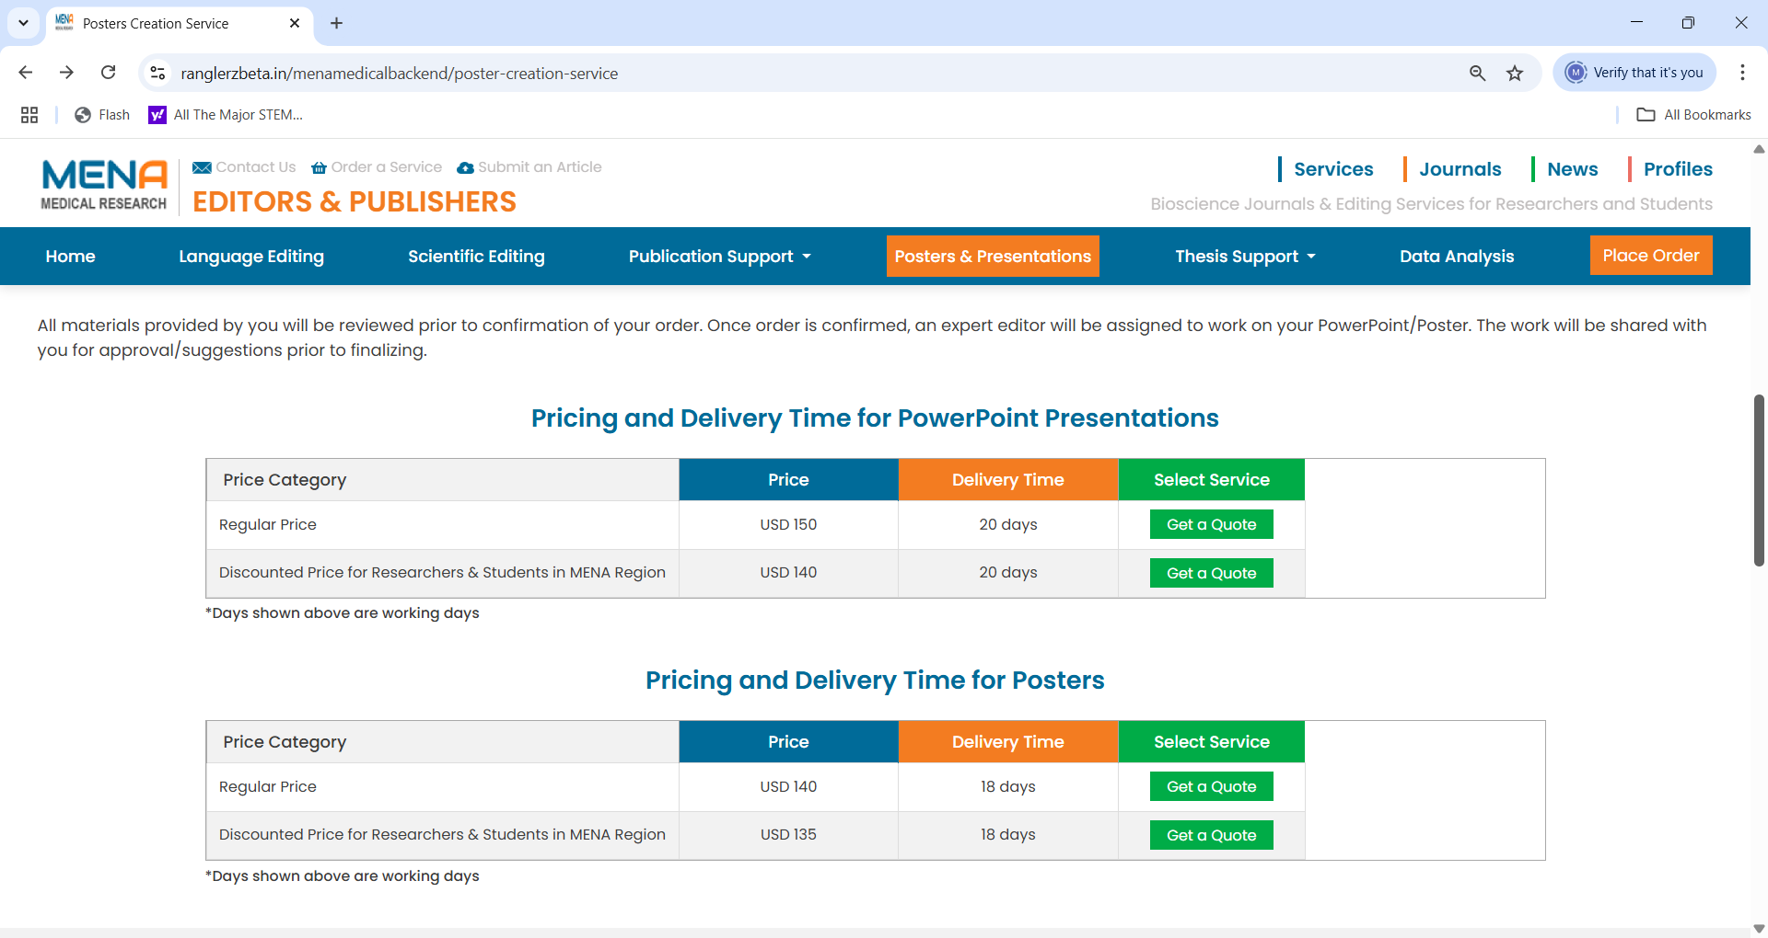

MENA Medical Research ensures price transparency for all its services. We ensure that you are aware of our service charges and make a fully informed decision before placing an order.

**Select**

**Select**

PowerPoint Presentation Service

Poster Creation Service

**Place Order & Pay**

You place order for required services and make the payment

You submit document for preliminary review and invoice creation

**Data Analysis**

**Select**

**Select**

You submit document for preliminary review and invoice creation

**Place Order & Pay**

You place order for required services and make the payment